**Practical 21**

Exercise

1) Write a program to demonstrate all the system broadcast messages.

**activity_main.xml File:**

<?xml version="1.0" encoding="utf-8"?>  
<androidx.constraintlayout.widget.ConstraintLayout xmlns:android="http://schemas.android.com/apk/res/android"  
 xmlns:app="http://schemas.android.com/apk/res-auto"  
 xmlns:tools="http://schemas.android.com/tools"  
 android:layout_width="match_parent"  
 android:layout_height="match_parent"  
 android:background="#4B4C4C"  
 tools:context=".MainActivity">  
  
 <TextView  
 android:id="@+id/tv1"  
 android:layout_width="118dp"  
 android:layout_height="89dp"  
 android:gravity="center"  
 android:textColor="@color/white"  
 android:textSize="30sp"  
 android:textStyle="bold"  
 app:layout_constraintBottom_toBottomOf="parent"  
 app:layout_constraintHorizontal_bias="0.754"  
 app:layout_constraintLeft_toLeftOf="parent"  
 app:layout_constraintRight_toRightOf="parent"  
 app:layout_constraintTop_toTopOf="parent"  
 app:layout_constraintVertical_bias="0.429" />  
  
 <TextView  
 android:id="@+id/textView"  
 android:layout_width="253dp"  
 android:layout_height="83dp"  
 android:gravity="center"  
 android:text="Battery Status "  
 android:textColor="@color/white"  
 android:textSize="30dp"  
 android:textStyle="bold"  
 app:layout_constraintBottom_toTopOf="@+id/tv1"  
 app:layout_constraintEnd_toEndOf="parent"  
 app:layout_constraintStart_toStartOf="parent"  
 app:layout_constraintTop_toTopOf="parent"  
 tools:ignore="MissingConstraints" />  
  
 <ImageView  
 android:id="@+id/imageView"  
 android:layout_width="141dp"  
 android:layout_height="106dp"  
 app:layout_constraintBottom_toBottomOf="parent"  
 app:layout_constraintEnd_toEndOf="parent"  
 app:layout_constraintHorizontal_bias="0.222"  
 app:layout_constraintStart_toStartOf="parent"  
 app:layout_constraintTop_toTopOf="parent"  
 app:layout_constraintVertical_bias="0.441"  
 app:srcCompat="@drawable/ch" />  
  
 <Button  
 android:id="@+id/button"  
 android:layout_width="wrap_content"  
 android:layout_height="wrap_content"  
 android:text="Check Battery"  
 android:textColor="#040303"  
 android:textSize="24sp"  
 android:textStyle="bold"  
 app:backgroundTint="#FFFCFC"  
 app:layout_constraintBottom_toBottomOf="parent"  
 app:layout_constraintEnd_toEndOf="parent"  
 app:layout_constraintHorizontal_bias="0.496"  
 app:layout_constraintStart_toStartOf="parent"  
 app:layout_constraintTop_toBottomOf="@+id/tv1"  
 app:layout_constraintVertical_bias="0.319" />  
  
</androidx.constraintlayout.widget.ConstraintLayout>

MainActivity.java File:

package com.example.brodcast;  
  
import androidx.appcompat.app.AppCompatActivity;  
  
import android.content.Intent;  
import android.content.IntentFilter;  
import android.os.Bundle;  
import android.view.View;  
import android.widget.Button;  
import android.widget.TextView;  
  
public class MainActivity extends AppCompatActivity {  
 TextView tv;  
 Button check;  
 BatteryReceiver;  
 @Override  
 protected void onCreate(Bundle savedInstanceState) {  
 super.onCreate(savedInstanceState);  
 setContentView(R.layout.activity_main);  
  
 tv=findViewById(R.id.tv1);  
 check=(Button)findViewById(R.id.button);  
 check.setOnClickListener(new View.OnClickListener() {  
 @Override  
 public void onClick(View v) {  
 batteryReceiver=new BatteryReceiver(tv);  
  
 registerReceiver(batteryReceiver,new IntentFilter(Intent.ACTION_BATTERY_CHANGED));  
  
 }  
 });  
  
 }  
  
 @Override  
 protected void onStop() {  
 super.onStop();  
 unregisterReceiver(batteryReceiver);  
 }  
}

**BatteryReceiver.java**

package com.example.brodcast;  
  
import android.content.BroadcastReceiver;  
import android.content.Context;  
import android.content.Intent;  
import android.widget.TextView;  
  
public class BatteryReceiver extends BroadcastReceiver {  
  
 TextView tv;  
  
 BatteryReceiver(TextView tv){  
  
 this.tv=tv;  
 }  
 @Override  
 public void onReceive(Context context, Intent intent) {  
 int percentage = intent.getIntExtra("level",0);  
 if(percentage!=0) {  
 tv.setText(percentage + "%");  
 }  
  
 }  
}

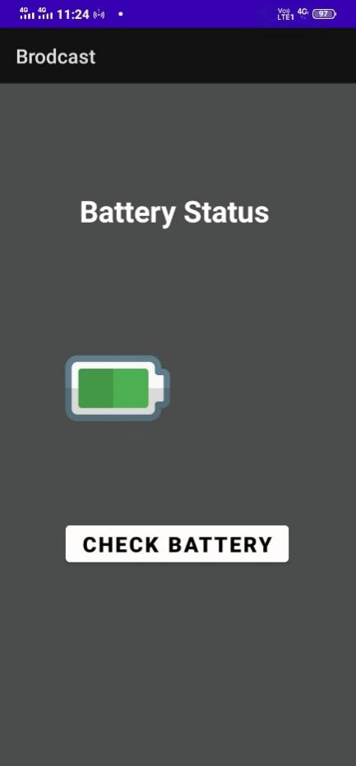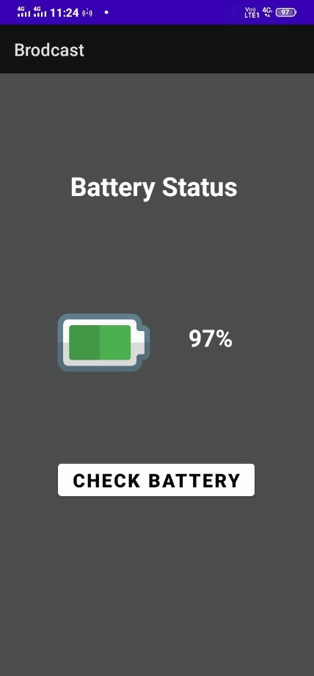**Output:**